**Question 7.1**

Describe a situation or problem from your job, everyday life, current events, etc., for which exponential smoothing would be appropriate. What data would you need? Would you expect the value of  (the first smoothing parameter) to be closer to 0 or 1, and why?

**Answer:**

I would like to give an example of Dam in my village for which exponential smoothing is appropriate. The village along with several other villages is situated on the banks of a river. The government there has built a Dam which controls the flow of the water in the river. It is because of this dam, the waters do not flow fast and the villagers can benefit for the agriculture process. The level of water there is measured between 0 -1000 units where if water level reaches 900 units and stays 900for a week the dam has to be opened to release water on the other side or else it can impact the ability of the dam to hold water. Level 800 is still not good for the villagers as well as it may end up flooding the village even though the dam can handle that level. So the government will still release the waters at 800 units. 700 units is the best scenario with no damage on either side with surplus water for the villagers. So releasing the DAM at 700 is advisable as no one is affected at 700.

The place has 4 months of monsoon from June to September where exponential smoothing is critical to judge if the dam has to be opened to release the water or not. Though the weather of the place is sometimes unpredictable, the weather department has currently installed advanced technology to predict rain levels, so as a result of it the randomness factor has decreased. Since the randomness is low, my smoothing parameter value would be low.

**Question 7.2**

Using the 20 years of daily high temperature data for Atlanta (July through October) from Question 6.2 (file temps.txt), build and use an exponential smoothing model to help make a judgment of whether the unofficial end of summer has gotten later over the 20 years. (Part of the point of this assignment is for you to think about how you might use exponential smoothing to answer this question. Feel free to combine it with other models if you’d like to. There’s certainly more than one reasonable approach.)

Note: in R, you can use either HoltWinters (simpler to use) or the smooth package’s es function (harder to use, but more general). If you use es, the Holt-Winters model uses model=”AAM” in the function call (the first and second constants are used “A”dditively, and the third (seasonality) is used “M”ultiplicatively; the documentation doesn’t make that clear).

**Answer:** Given below are the steps performed to build an exponential smoothing model.

**Step 1:** Load the dataset

**Code:**

*library(data.table)*

*AtlantaTemp = read.table("C://Users/D100793/Desktop/Junk/Georgia Tech/Introduction To Analysis/temps.txt", header = TRUE,sep = '\t')*

*head(AtlantaTemp)*

**OUTPUT:**

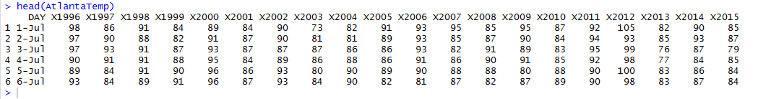

**Step 2:** Convert the data into Time Series data and plot it. Here we consider data from column 2 to column 21 as those columns year columns which have temperature values.

**CODE:**

*AtlantaTempVector = as.vector( unlist( AtlantaTemp[ , 2:21 ] ) )*

*AtlantaTempVectorTS = ts( AtlantaTempVector, start = 1996, frequency = 123 )*

*plot.ts( AtlantaTempVectorTS )*

**OUTPUT:**

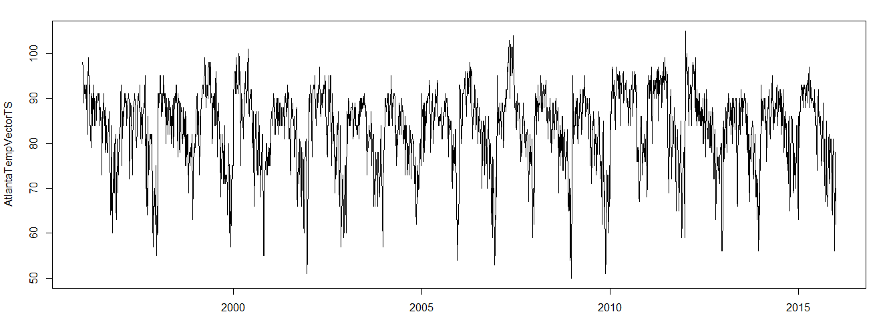

**Step 3:** Using exponential smoothing model using Holt Winters technique

**CODE:**

*EsModel= HoltWinters( AtlantaTempVectorTS, alpha = NULL, beta = NULL, gamma = NULL, seasonal = "multiplicative")*

*#Plotting moder*

*EsModel*

*plot(EsModel)*

**OUTPUT:**

Smoothing parameters:

alpha: 0.615003

beta : 0

gamma: 0.5495256

Coefficients:

[,1]

a 73.679517064

b -0.004362918

s1 1.239022317

s2 1.234344062

s3 1.159509551

**.**

**.**

**.**

s122 0.851581233

s123 0.874038407

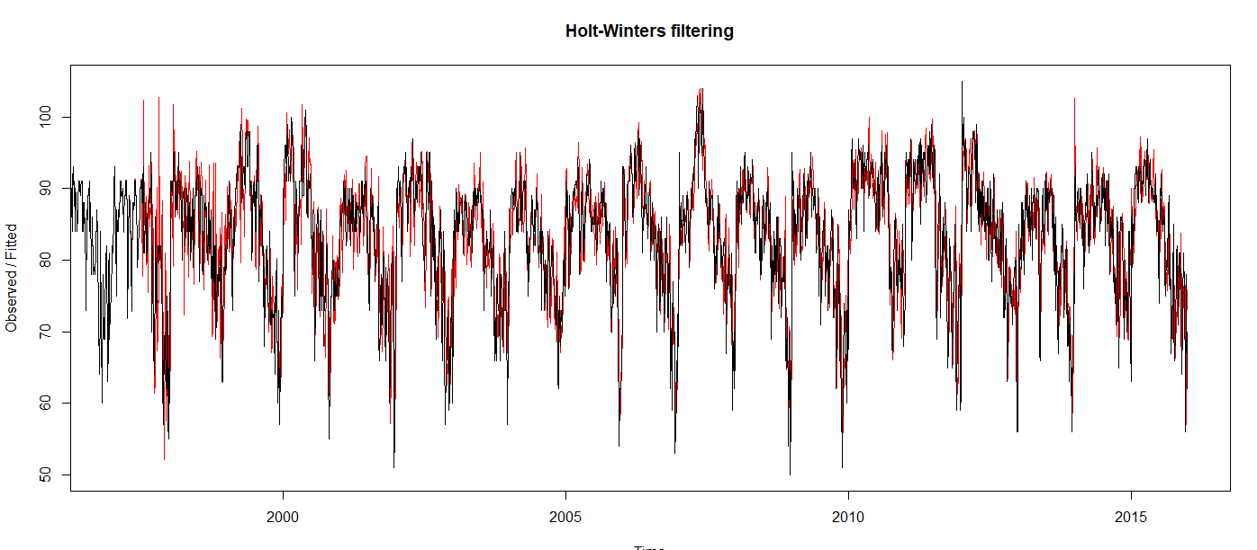

**Step 4:** Fitting the model

**CODE:**

*EsOutput = EsModel$fitted*

*plot( EsOutput)*

**OUTPUT:**

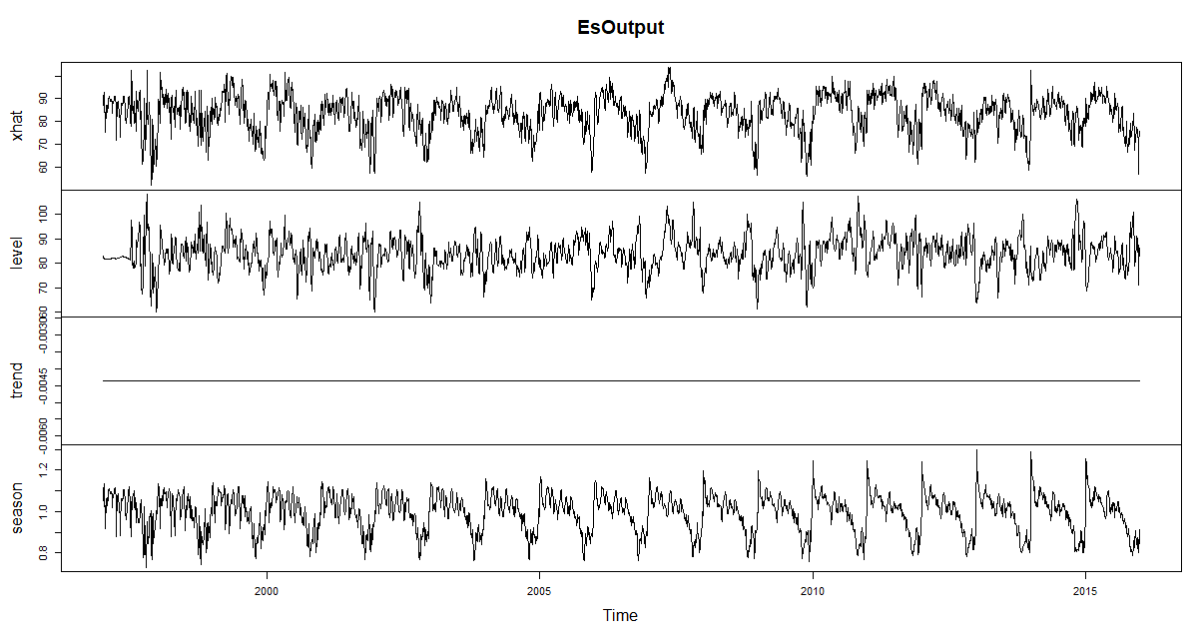

**Step 5:** Fetching the seasonal column out of the fitter data and exporting it to excel (csv file)

**CODE:**

*EsOutput_Seasonal = matrix(EsOutput[,4],nrow = 123)*

*write.csv( EsOutput_Seasonal, file = "EsOutput.csv" )*

**OUTPUT:**